Linux Lab 14
Linux Command-Line Fundamentals – File System Navigation, File Management & Permissions

Objective
The objective of this lab was to develop practical Linux command-line skills by working with directories, files, file permissions, and file ownership.
The lab focused on using basic Linux commands such as pwd, ls, cd, mkdir, touch, cp, mv, rm, chmod, and chown. These commands provide the foundation for Linux system administration and are frequently used when working with servers, logs, permissions, and security-related tasks.

Lab Environment
Component | Details
Linux Machine | Ubuntu-Lab
Operating System | Ubuntu Linux
Linux User | labuser
Domain Controller | DC-Server
User Password | P@ssw0rd123
Terminal | Linux Terminal
Commands Practiced | pwd, ls, cd, mkdir, touch, cp, mv, rm, chmod, chown

Part 1: Starting the Virtual Machines
Step 0: Start Your VMs
Procedure
- Started the DC-Server virtual machine.
- Waited for the server to finish booting.
- Logged in using:
Username: mydomain\Administrator
- Started the Ubuntu-Lab virtual machine.
- Logged in using:
Username: labuser
Password: P@ssw0rd123
Expected Terminal
After logging in, the terminal should display something similar to:
labuser@ubuntu-lab:~$
Result
The Ubuntu-Lab VM was successfully started and the labuser account was successfully logged in.
Screenshot 1: Ubuntu terminal showing labuser@ubuntu-lab:~$ 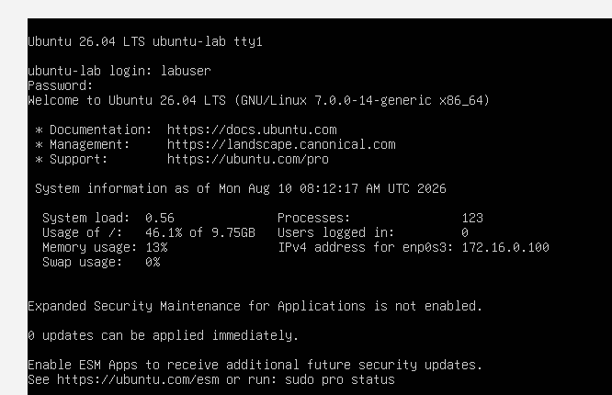

Part 2: Linux File System Navigation
Step 1: Display the Current Working Directory
Command
pwd
Expected Output
/home/labuser
Observation
The pwd command displays the current working directory.
In this case, the user is located inside:
/home/labuser
Result
The current working directory was successfully identified.
Screenshot 2: pwd command showing /home/labuser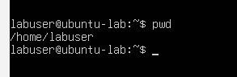

Step 2: List Files Including Hidden Files
Command
ls -la
Observation
The command displays files and directories, including hidden files.
Example:
drwxr-xr-x
drwxr-xr-x
-rw-r--r--
-rw-r--r--
-rw-r--r--
Important information displayed includes:
- File permissions
- Number of links
- Owner
- Group
- File size
- Modification date
- File name
Permission Symbols
Symbol | Meaning
- | Regular file
d | Directory
l | Symbolic link
r | Read
w | Write
x | Execute

Result
The contents of the home directory, including hidden files, were successfully displayed.
Screenshot 3: ls -la output
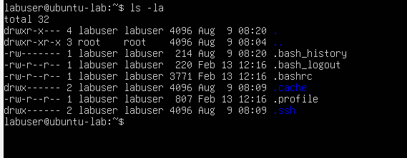
Step 3: Navigate to the Root Directory
Command
cd /
Then:
pwd
Expected Output
/
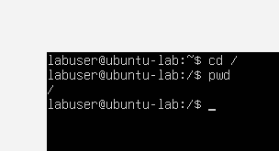
The / directory represents the root directory of the Linux file system.

Next, execute:
ls
Expected Directories
You may see directories such as:
bin
boot
dev
etc
home
lib
media
mnt
opt
proc
root
run
sbin
srv
sys
tmp
usr
var
Observation
The root directory contains the main directory structure of the Linux operating system.
Result
Successfully navigated from the user's home directory to the Linux root directory.

Step 4: Navigate to /var/log
Command
cd /var/log
Then:
pwd
Expected Output
/var/log
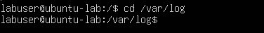
Next:
ls -la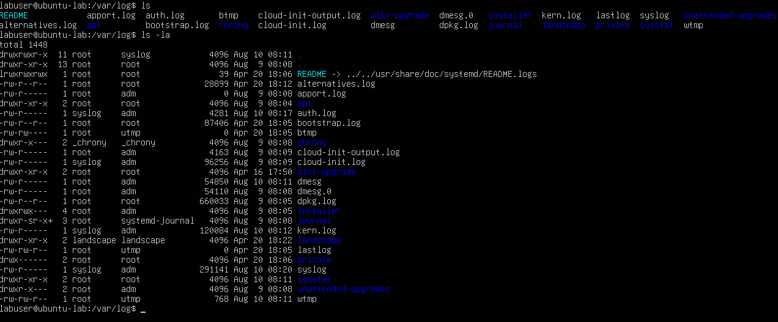
Observation
The /var/log directory contains system and application logs.
Depending on the Ubuntu version and configuration, files may include:
auth.log
syslog
kern.log
dpkg.log
Result
Successfully navigated to the Linux log directory and inspected its contents.
Step 5: Return to the Home Directory
Command
cd ~
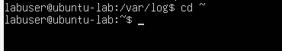
Then:
pwd
Expected Output
/home/labuser
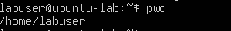
Observation
The ~ symbol represents the current user's home directory.
For labuser:
~ = /home/labuser
Result
Successfully returned to the user's home directory.

Part 3: File and Directory Management
Step 6: Create a Directory
Command
mkdir myfolder
Then:
ls
Observation
A new directory named:
myfolder
appeared in the home directory.
Result
A directory was successfully created using mkdir.
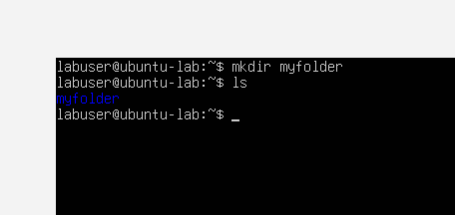

Step 7: Create an Empty File
Command
touch myfile.txt
Then:
ls
Observation
A new empty file named:
myfile.txt
was created.
Result
Successfully created an empty file using touch.
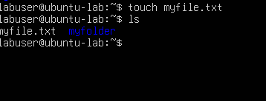

Step 8: Copy a File
Command
cp myfile.txt myfile_copy.txt
Then:
ls
Observation
Two files were now present:
myfile.txt
myfile_copy.txt
The cp command created a copy of the original file.
Result
The file was successfully copied.
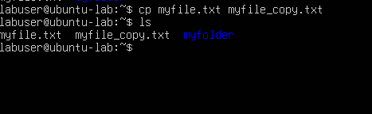
Step 9: Move a File
Command
mv myfile_copy.txt /tmp/
Then verify:
ls
The copied file should no longer appear in the home directory.
Next:
ls /tmp/
Observation
myfile_copy.txt was moved from /home/labuser to /tmp.
Result
The file was successfully moved to the /tmp directory.
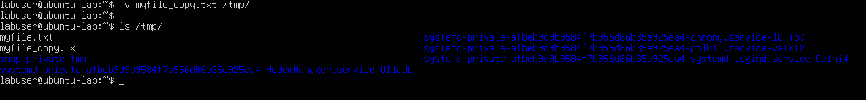

Step 10: Remove a File
Command
rm myfile.txt
Then:
ls
Observation
The myfile.txt file was removed from the home directory.
Result
The file was successfully deleted using the rm command.
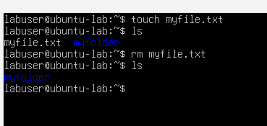

Part 4: Linux File Permissions
Step 11: Create a New File and Check Permissions
Since myfile.txt was deleted in the previous step, create it again:
touch myfile.txt
Then:
ls -l myfile.txt
Expected Output
The output should be similar to:
-rw-r--r-- 1 labuser labuser 0 Aug 10 10:15 myfile.txt
Permission Breakdown
-rw-r--r--
│
├── rw- → User/Owner
├── r-- → Group
└── r-- → Others
Permission | Meaning
- | Regular file
rw- | User can read and write
r-- | Group can read
r-- | Others can read
Observation
The file owner is labuser, and the default permissions allow the owner to read/write while group and other users have read-only access.
Result
File permissions and ownership were successfully inspected.
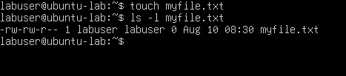
Step 12: Change File Permissions Using chmod
Command
chmod 755 myfile.txt
Then:
ls -l myfile.txt
Expected Output
-rwxr-xr-x 1 labuser labuser 0 Aug 10 10:15 myfile.txt
Understanding 755
The permission value is:
755
It can be divided into:
7 5 5
│ │ │
User Group Others
Number | Permission | Meaning
7 | rwx | Read, Write, Execute
5 | r-x | Read, Execute
5 | r-x | Read, Execute
Observation
The chmod command changed the file permissions so that:
- Owner → Read, Write, Execute
- Group → Read, Execute
- Others → Read, Execute
Result
File permissions were successfully modified using chmod.
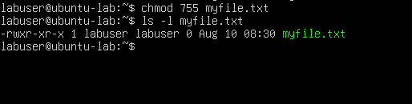
Step 13: Change File Ownership Using chown
Command
chown labuser:labuser myfile.txt
Observation
The command ensures that:
Owner: labuser
Group: labuser
The ownership was already expected to be configured this way because the file was created by labuser, but the command provided practical experience with ownership management.
Result
The file ownership was successfully verified/set to:
labuser:labuser
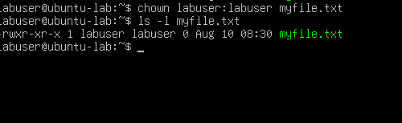

Command Summary
Command | Purpose
pwd | Displays the current working directory
ls -la | Lists files including hidden files
cd / | Navigates to the root directory
cd /var/log | Navigates to the log directory
cd ~ | Returns to the user's home directory
mkdir myfolder | Creates a directory
touch myfile.txt | Creates an empty file
cp | Copies a file
mv | Moves a file
rm | Removes a file
ls -l | Displays detailed file information
chmod | Changes file permissions
chown | Changes file ownership

Troubleshooting / Observations
Task | Observation | Result
pwd | Displayed /home/labuser | ✅ Successful
ls -la | Displayed files and permissions | ✅ Successful
cd / | Navigated to root | ✅ Successful
cd /var/log | Accessed system logs | ✅ Successful
cd ~ | Returned to home directory | ✅ Successful
mkdir | Created myfolder | ✅ Successful
touch | Created myfile.txt | ✅ Successful
cp | Created file copy | ✅ Successful
mv | Moved file to /tmp | ✅ Successful
rm | Deleted file | ✅ Successful
chmod 755 | Changed file permissions | ✅ Successful
chown | Set ownership | ✅ Successful

Key Takeaways
1. Linux File System Navigation
Linux uses a hierarchical file system beginning at:
/
The user's home directory was:
/home/labuser
and system logs were located under:
/var/log

2. File Permissions
Linux permissions use three primary categories:
User → Group → Others
For example:
-rwxr-xr-x
means:
User: rwx
Group: r-x
Others: r-x

3. Numeric Permissions
The chmod 755 command uses numeric permission values:
7 = rwx
5 = r-x
5 = r-x
Therefore:
755 = rwxr-xr-x

4. File Ownership
Linux files have an owner and group.
Example:
labuser labuser
The chown command can be used to change ownership.

Skills Demonstrated
- Linux Command Line
- Linux File System Navigation
- File and Directory Management
- Linux File Permissions
- Linux File Ownership
- chmod
- chown
- ls
- cd
- pwd
- mkdir
- touch
- cp
- mv
- rm
- Linux Log Directory Analysis
- Basic Linux System Administration

Conclusion
This lab provided hands-on experience with fundamental Linux command-line operations. The exercises covered navigating the Linux file system, viewing files and hidden files, creating and managing directories and files, copying and moving files, deleting files, and working with Linux file permissions and ownership.
The lab also provided practical exposure to the /var/log directory, which is particularly important in cybersecurity because Linux system and authentication logs can be analyzed during security monitoring and incident investigations.
By completing this lab, practical skills were developed in Linux administration, file system management, permission management, ownership management, and command-line navigation, providing a foundation for further Linux and cybersecurity labs.

